INSTRUCTIONS
BIG WHEEL SHOP DOLLY
ASSEMBLY INSTRUCTIONS
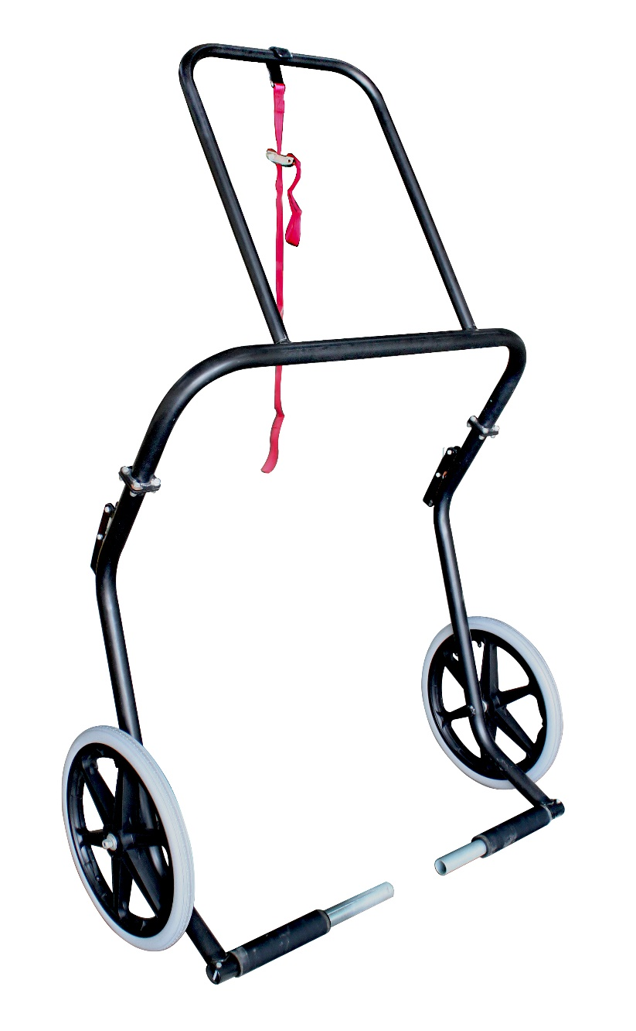
Install the washers first, then slide the wheels onto the axle
and secure with the nyloc nut. Do not over tighten, or the wheels will not be free rolling.

Install the dolly legs. Secure them with the 5/16 nuts and bolts.

Install the handle. Secure it with the self-tapping screws, placed in the pre-drilled holes in the handle.

Install the support strap by wrapping the twisted sewn end of the strap over the handle, and slip the buckle through the loop. Make sure that when the strap hangs down, the hook is facing forward.

** FOR INDOOR USE ONLY.
** CAPACITY: 440LBS (220/KGS)

